41.49: a) The minimum wavelength means the largest transition energy. If we assume that the electron makes a transition from a high shell, then using the screening approximation outlined in Section 41.5, the transition energy is approximately the ionization energy of hydrogen. Then 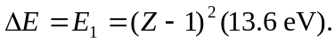For vanadium, Z = 23.
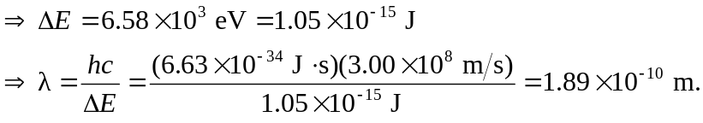
For the longest wavelength, we need the smallest transition energy, so this is the 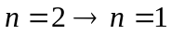 transition 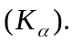 So we use Moseley’s Law:
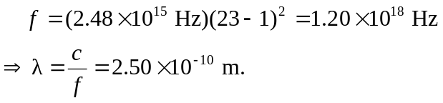
b) The rhenium, Z = 45, the minimum wavelength is
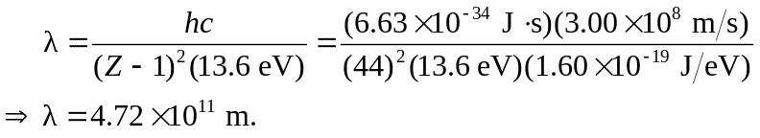
The maximum wavelength is 